8/14/2023

Tabitha Hagen

UNCW BAN 530 APPLICATIONS IN BUS ANALYTICS

Market Saturation Report on Restaurants in

Bengaluru (aka Bangalore), India

## Objectives –

* Examine employee schedules in the Residency Road area using Excel’s Solver Tool.
  + Possible Employee Scheduling:
    - How many employees should work in a non-training schedule?
    - How many employees should work in the training schedule?

## Prescriptive Analytics – How many employees should work each shift?

### **Choosing a Location**

* + Lavelle Road and Residency Road have both been shown as locations that need growth in earlier parts of this report, however, Residency Road has made some sincere investment in making this part of the Central Business District (CBD). Tender S.U.R.E. has made it more pedestrian friendly[1], which makes it a perfect location for commercial investment. Residency Road was named for the actual residence of the British representative who governed the region and has become a great location surrounded by prestigious schools[2] while staying connected to other important sections of the CBD. The customer base here will be strong as there are many families commuting to the Bishop Cotton Boys School, St. Joseph’s Boys High School, Sacred Heart Girls High School, as well as St. Patrick’s High School.

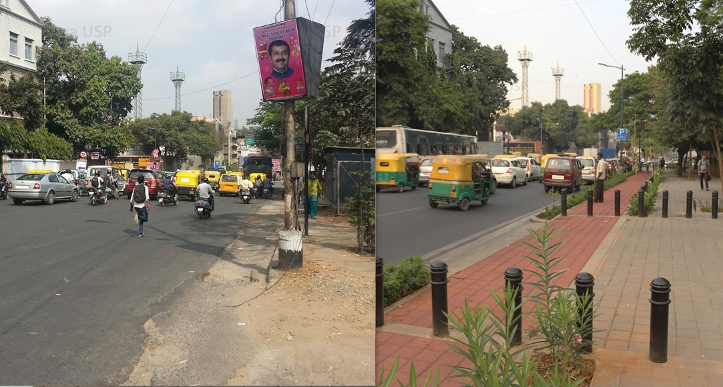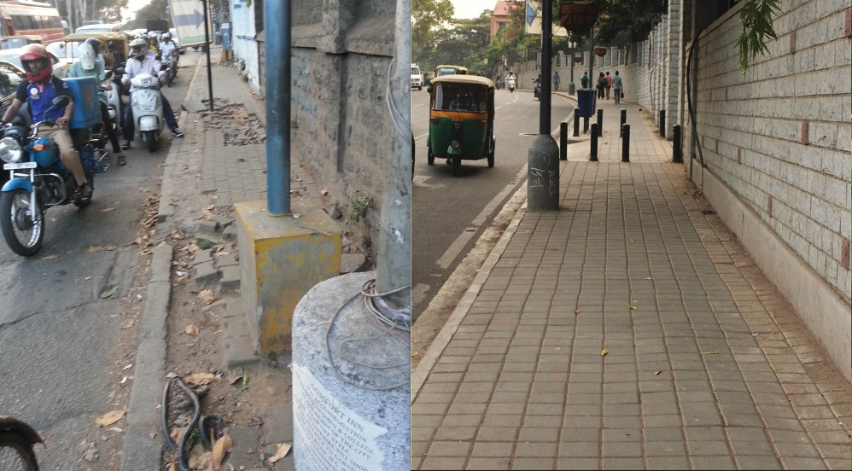

Figure 2 On the left, the old roads of Residency Road compared with new roads with curbing on the right.

Figure 1 On the left, the old sidewalks of Residency Road compared with new sidewalks on the right.

### **Comparing Competitors**

* + **A diagram of a number of employees needed

    Description automatically generated**As previously shown in this report, there are not many Dessert Restaurants from the Zomato surveys in the Residency Road area and an ideal Dessert Restaurant would have an offering of chocolate brownies, cakes, and/or artisan chocolates. There are a few ice cream stores like the Corner House Ice Cream Franchises which are open 11am – 11pm Monday through Sunday, according to Google. There is also a Chocolatier like Fabelle Exotic Chocolates which is temporarily closed. In alignment with the local school hours, a suggested business schedule to begin for your proposed Dessert restaurant is **9am to 9pm**. This allows the customer base to be the parents who just dropped off their students to have a morning meeting, cater to the after-lunch dessert crowd as well as the patrons who like desserts before and after dinner. In order to have fresh baked goods to sell, it is required that a 2-hr PREP time be implemented for a minimum of 3 people to start off the day. At the end of the day, it would also take 3 people an extra hour past closing to finish cleaning up (they could start cleaning at 8pm, depending on the rate of customers).

Figure 3 This line graph shows the expected level of employees needed throughout a typical workday schedule. FT means Full-time employee and PT means Part-Time employee.

### **Non-Training Hours Schedule –** using Excel’s Solver Tool

* The hourly rates in the top right corner of Figures 4 and 5 show a General Part-Time wage of ₹88 which is based upon the current wage of ₹87.02 for Restaurant staff salary in Bengaluru listed by Indeed.com[3]. Those who work the shifts involving Prep or cleaning get an increased pay at ₹88 as an incentive to work those needed shifts. Additionally, the full-time managerial shifts are paid ₹100 per hour but this may later be changed to a salary.
* **A screenshot of a computer

  Description automatically generated**The chart in Figure 4 shows an optimized work schedule which utilizes a maximum of 2 Full-time managerial employees and up to 15 Part-time employees. On the left of the chart is each hour of the workday and at the top of the chart in orange are the rows detailing how many employees for each shift should optimally be scheduled. Generally, there are 2 part-time employees for each shift, unless it says 0.5 which means there is only 1 employee for that slot. The optimized number of employees required is the full-time Manager and Assistant Manager who work 8-hour shifts plus 10 Part-time workers who work 4 or 5 hours a day. This minimizes the labor cost of the restaurant which is shown at the bottom left of the chart.

Figure 4 This table shows the OPTIMAL number of employees and their shifts. FT means Full-time employee and PT means Part-Time employee.

**Training Hours Schedule** **–** using Excel’s Solver Tool

* The hourly rates in Figure 5 add in a full-time non-managerial employee who gets paid ₹92 per hour. This could be a kitchen manager or an assistant manager in training and they are aligned with the closing time of the workday.
* A close-up of a document

  Description automatically generatedThe chart in below in Figure 5 shows an optimized work schedule which utilizes a maximum of 2 Full-time managerial employees, 1 non-managerial employees and up to 15 Part-time employees. On the left of the chart is each hour of the workday and at the top of the chart in orange are the rows detailing how many employees for each shift should optimally be scheduled. Generally, there are either 1 or 2 part-time employees for each shift, and where it says 0.5, there is only 1 employee for that slot. The optimized number of employees required is the full-time Manager, the Assistant Manager and 1 more employee who work 8-hour shifts plus 9 Part-time workers who work 4 or 5 hours a day. This minimizes the labor cost of the restaurant which is shown at the bottom left of the chart. Note the 6 under the “Optimized Staff” column for the employee coverage between 3-4pm; this allows workers to have training time during a slower point of the workday. This opportunity provides the availability to hire some of the nearby students to work afternoon shifts after their full school day.

Figure 5 This table shows the OPTIMAL number of employees and their shifts during a sample training schedule. FT means Full-time employee and PT means Part-Time employee.

## Prescriptive Analytics – How many employees should work each shift?

## Residency Road has a prestigious history, increased pedestrian access, and a vibrant community with plenty of potential customers nearby making it a prime location to open a Dessert focused restaurants with an offering of chocolate brownies, cakes, and/or artisan chocolates. Proposed are two different shifts, one for training and one standard employee schedule. Both schedules require a Full-time Manager and Assistant Manager, which allows one to open the business with the required Prep and the other to close with the required Cleaning. One schedule allows employee overlap for training purposes. Choosing a location within the prestigious school community allows opportunities to fill the part-time shifts with parents who need shorter hours yet stay near to their children or teens who need after-school work. Incorporating members of those communities will also quickly encourage their peers and other family members to visit your establishment.

Figure 6 This chart summarizes the previous two tables.

1. <https://www.janausp.org/portfolio/residency-road/>
2. <https://roofandfloor.thehindu.com/raf/real-estate-blog/neighbourhood-focus-residency-road-bangalore/>
3. <https://in.indeed.com/career/restaurant-staff/salaries/Bengaluru--Karnataka>